

Practices for Secure Software Report

Table of Contents
Document Revision History 3
Client 3
Instructions 3
Developer 4
1. Algorithm Cipher 4
2. Certificate Generation 4
3. Deploy Cipher 4
4. Secure Communications 4
5. Secondary Testing 4
6. Functional Testing 4
7. Summary 4
8. Industry Standard Best Practices 4

Document Revision History

Version | Date | Author | Comments
1.0 | 10/6/2025 | Michael King | Updated the report.
1.1 | 10/8/2025 | Michael King | Updated the report.
1.2 | 10/9/2025 | Michael King | Updated the report.
1.3 | 10/10/2025 | Michael King | Updated the report.
2.0 | 10/16/2025 | Michael King | Finalized the report.

Client



Developer
Michael King

Algorithm Cipher

After evaluating Artemis Financial’s needs and the overall system, I believe the best encryption cipher is the Advanced Encryption Standard, or AES. This cipher is recognized as the most secure algorithm for protecting sensitive data. It is also used by the U.S. government to encrypt classified information (Awati et al., 2024). Hash functions convert input data into a sequence of characters known as the hash value (GeeksforGeeks, 2025b). Bit levels determine the encryption’s strength. Artemis Financial should consider using AES-256 because it provides maximum protection.

Random numbers construct unpredictable keys essential for strong encryption. Symmetric keys are less secure than asymmetric keys because they rely on a single key for both the encryption and decryption of data. In contrast, asymmetric keys are more secure because they use two keys: the public key for encrypting data and the private key for decrypting it (GeeksforGeeks, 2025a). The history of data encryption algorithms began with the Data Encryption Standard (DES), which was introduced as the first widely recognized encryption algorithm in 1975. It was also the first encryption algorithm to be certified by the National Institute of Standards and Technology and introduced by the US government in 1977. The DES remained the standard until it was replaced by the Advanced Encryption Standard in 2001 as a more secure algorithm (Schneider, 2025).

Certificate Generation

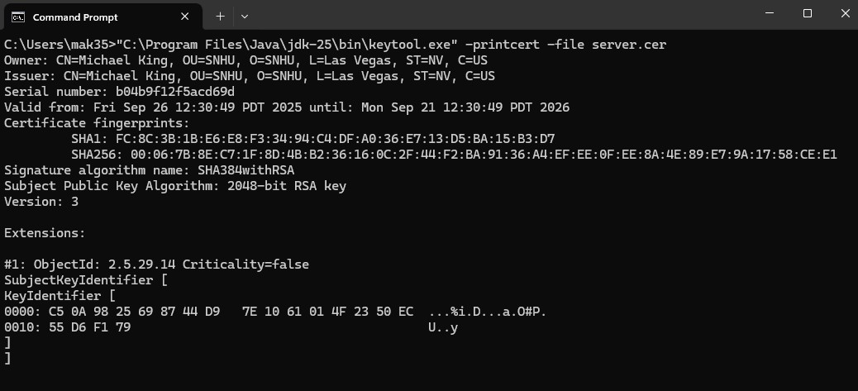

Deploy Cipher

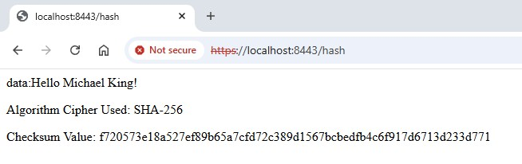

Secure Communications



Secondary Testing

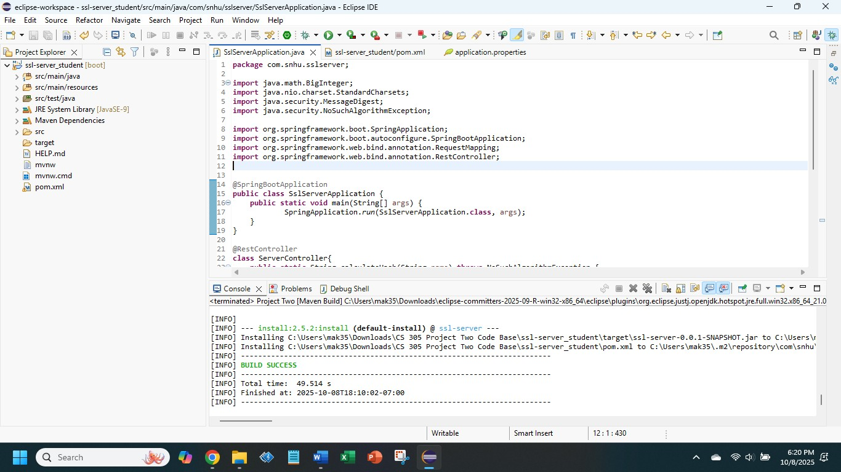

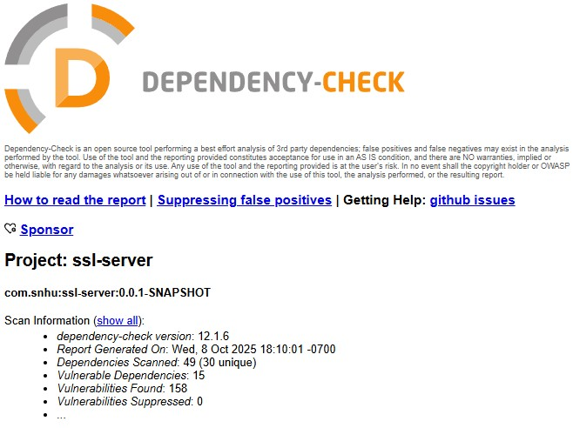
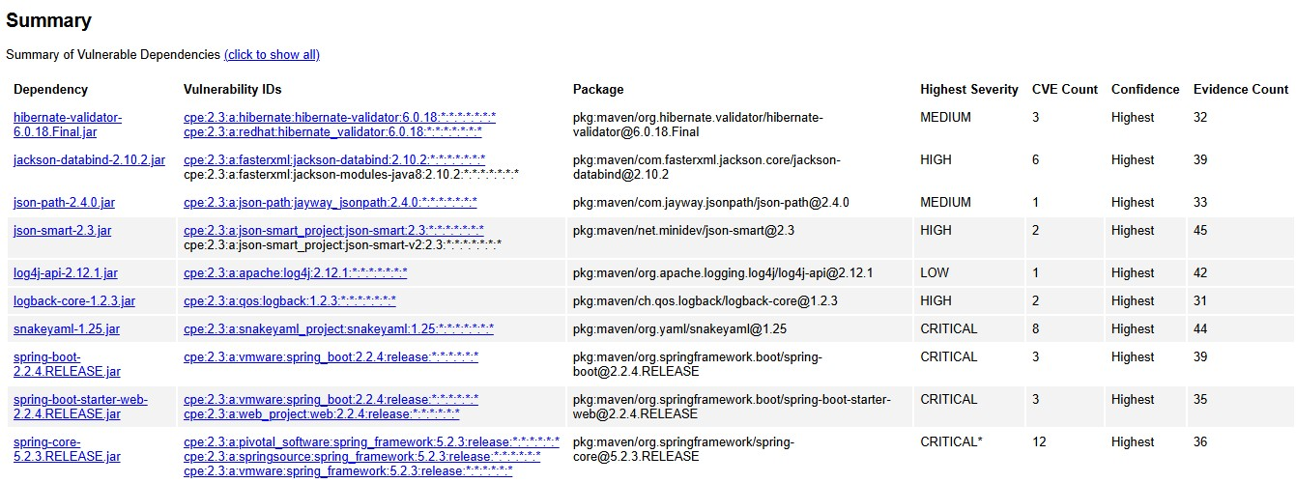
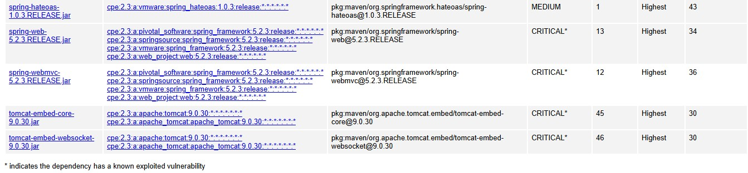

Functional Testing

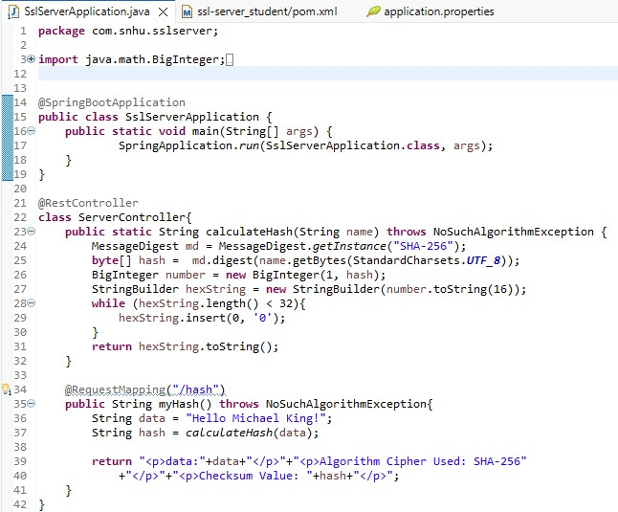
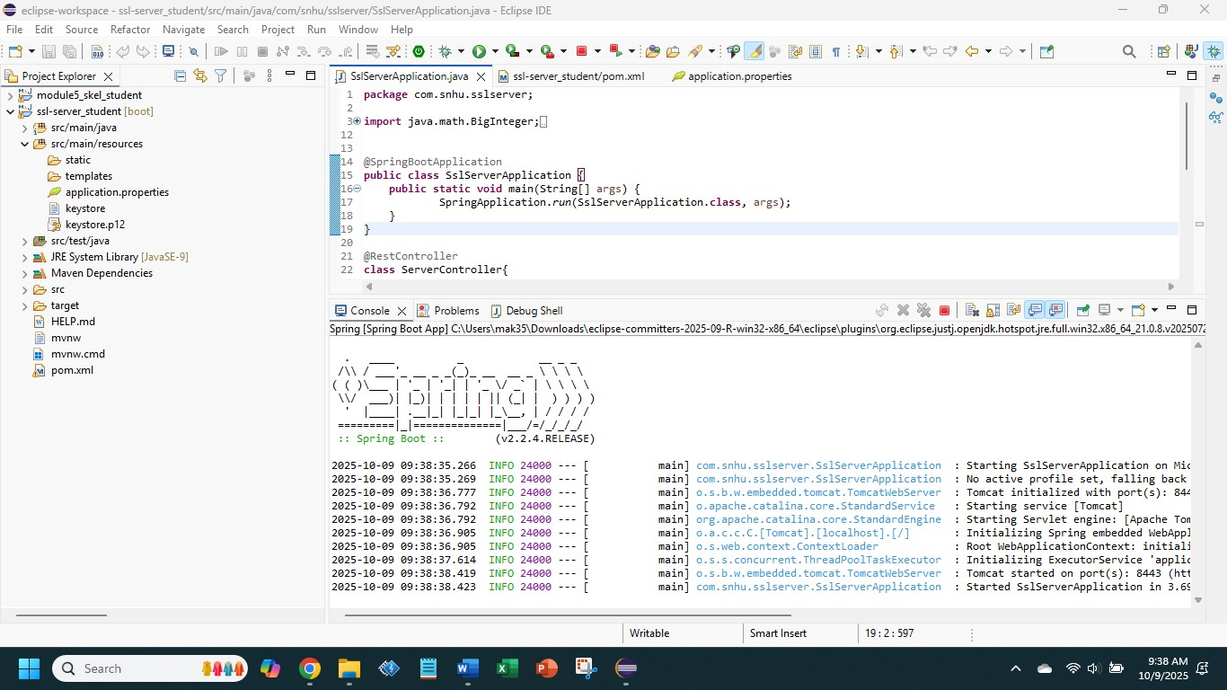

Summary

While refactoring the code, I added a RestController annotation to build the RESTful web service for client-server communications. During secondary testing, several vulnerabilities were discovered in the dependency check. During functional testing, the code was thoroughly reviewed to ensure its successful implementation. The process for adding layers of security to the software application required improvements. I refactored the dependency check in pom.xml to its latest version to detect all vulnerabilities. For the Spring Boot application, I used SHA-256 as the cryptographic hash function and HTTPS to enhance data transmission. After adding those security layers, I confirmed that all security measures adhere to encryption standards. I verified that secure communications were consistent throughout this application. This approach not only protected sensitive information but also helped meet industry standards, strengthening the security of Artemis Financial.

Industry Standard Best Practices

To address known security vulnerabilities, I applied industry-standard best practices to the software application. The first one is input validation, where Artemis Financial must verify the owner of the information, which helps protect users. This not only ensures that only authorized users can access their information but also prevents SQL injection and cross-site scripting (XSS) attacks (GeeksforGeeks, 2025c). Since Artemis Financial’s software operates both internally and externally, it communicates data through a secure API. Cryptography is one of the most critical cybersecurity techniques used to ensure the confidentiality and integrity of user data. I applied the SHA-256 algorithm to the software application as it is the most secure in the SHA-2 family. It is known for its resistance to cryptographic attacks (GeeksforGeeks, 2025d). Code errors must be identified to detect security threats. To ensure the algorithm is found, I added NoSuchAlgorithmException to the code. Code quality is another factor to consider when working with code. This ensures authorized method access, allowing only authorized users to access their information. It also ensures that developers can easily read the code. By applying these practices, this software can maintain the integrity of user data in a company like Artemis Financial.

References:

Awati, R., Bernstein, C., & Cobb, M. (2024, February 20). Advanced Encryption Standard (AES). Search Security. https://www.techtarget.com/searchsecurity/definition/Advanced-Encryption-Standard

GeeksforGeeks. (2025a, July 12). Difference between symmetric and asymmetric key encryption. GeeksforGeeks. https://www.geeksforgeeks.org/computer-networks/difference-between-symmetric-and-asymmetric-key-encryption/

GeeksforGeeks. (2025b, July 23). Cryptography hash functions. GeeksforGeeks. https://www.geeksforgeeks.org/competitive-programming/cryptography-hash-functions/

GeeksforGeeks. (2025c, July 23). What is Input Validation Attack? GeeksforGeeks. https://www.geeksforgeeks.org/ethical-hacking/what-is-input-validation-attack/

GeeksforGeeks. (2025d, August 7). Cryptography and its Types. GeeksforGeeks. https://www.geeksforgeeks.org/computer-networks/cryptography-and-its-types/

Schneider, J. (2025, September 16). Cryptography History. IBM. https://www.ibm.com/think/topics/cryptography-history

